Assignment 4 (105 points)
Due 11:59 pm on Monday June 8th, 2026
Part A: Code Orientation (15 points)
- (3 pts) The line 𝑑𝑡 = 1/𝑔𝑎𝑛𝑡𝑟𝑦_𝑠𝑝𝑒𝑒𝑑 computes the time per degree of gantry rotation. For 𝑔𝑎𝑛𝑡𝑟𝑦_𝑠𝑝𝑒𝑒𝑑 = 540°/𝑠 and 𝑎𝑛𝑔𝑢𝑙𝑎𝑟_𝑟𝑎𝑛𝑔𝑒 = 0:179, what is the total acquisition time? Compare this to the typical rotation time of a modern clinical CT scanner for cardiac acquisitions and comment on whether this is a realistic timescale.
% A1-----------------------------------------------------------------------
% Caclulate total acquisition time
gantry_speed = 540; % degrees/s
dt = 1/gantry_speed;
angular_range = 0:179; % 180 projections
num_projections = length(angular_range);
total_acquisition_time = num_projections * dt;
disp(total_acquisition_time)

  - Total acquisition time = 0.3333s for 180 degrees
  - According to the assignment, modern scanners currently achieve 0.23-0.35 s/revolution, equivalent to ~1000-1500 degrees/s. This means this theoretical scanner is much slower since it takes twice the amount of time to rotate a full revolution (360 degrees).

- (3 pts) Calculate the total displacement (magnitude) of the object in mm and in pixels (assume pixel spacing = 0.5 mm) over the acquisition window determined from question A1. Show your work.
% A2-----------------------------------------------------------------------
% Calculate the total displacement of the object in mm and in pixels
vx = 40; % mm/s
vy = 40; % mm/s
ax = 40; % mm/s
ay = 40; % mm/s^2
t = total_acquisition_time;
Sx = vx*t + (1/2) * ax * t^2;
Sy = vy*t + (1/2) * ay * t^2;
% Magnitude (not really needed since Sx=Sy)
S = sqrt(Sx^2 + Sy^2);
disp(S)

% Convert to pixels
pixel_spacing = 0.5; % mm
S_pixels = S/pixel_spacing;
disp(S_pixels)

  - Total displacement of the object: 21.9989 mm
  - Total displacement of the object: 43.9978 mm
- (3 pts) Inside the projection loop, why is a fresh blank image (𝑖𝑚𝑔 = 𝑧𝑒𝑟𝑜𝑠(𝑁)) created on every iteration rather than reusing the previous one? Describe qualitatively what would happen to the sinogram if the previous frames were not cleared.
  - A fresh blank image is created at each iteration so that each projection represents the object at a single position in time. Because the Radon transform integrates all nonzero pixel values along the projection ray, if previous frames weren’t cleared, the image would hold or accumulate the object’s past positions, resulting in multiple overlapping objects in each projection. This would corrupt the sinogram by introducing signals from multiple positions simultaneously (including the past positions), leading to severe blurring, streaking, and duplication artifacts in the reconstructed image.

- (6 pts) Is this truly a half-scan in the sense used in clinical cardiac CT? If so, justify your answer. If not, propose a more realistic angular range for a clinical half-scan reconstruction and explain the discrepancy between the half-scan range used in this simulation and your proposed range.
  - This is not truly a half-scan used in clinical cardiac CT. The simulation uses an angular range of 180°, but this assumes a parallel-beam system rather than the fan-beam geometry used in real CT scanners. In the simulation, the parallel beam for 180° is enough because projections at θ and θ + 180° contain the same information, so the data is the same. However, clinical CT uses a fan beam, where additional angular coverage is needed to make sure all parts of the object are fully sampled. In reality, a half-scan requires 180° plus the fan angle. So, if the fan angle is around 60°, the total angular range would be 240°, meaning the simulation is more of an approximation.

Part B: Experiments (80 points)
- Display the reconstructed image of the 3 x 3 square object using the default parameters (no motion).
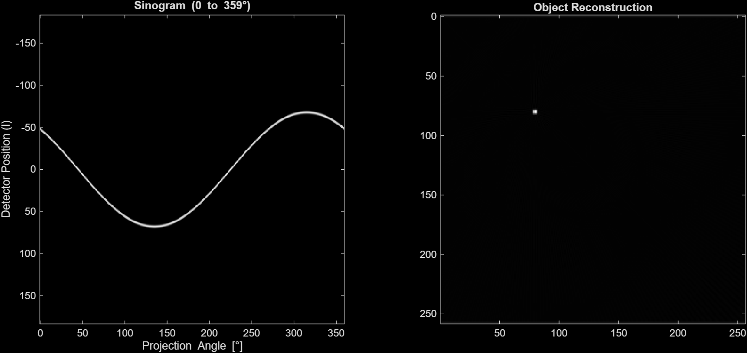

- Keeping all other parameters at their default values, run the simulation for 𝑣⃗ = [10, 20, 40, 80] 𝑚𝑚/𝑠 in the x-direction, i.e., 𝑣𝑦 = 0.
  - (8 pts) Attach the sinogram and reconstructed image for each velocity.
    - vx = 10mm/s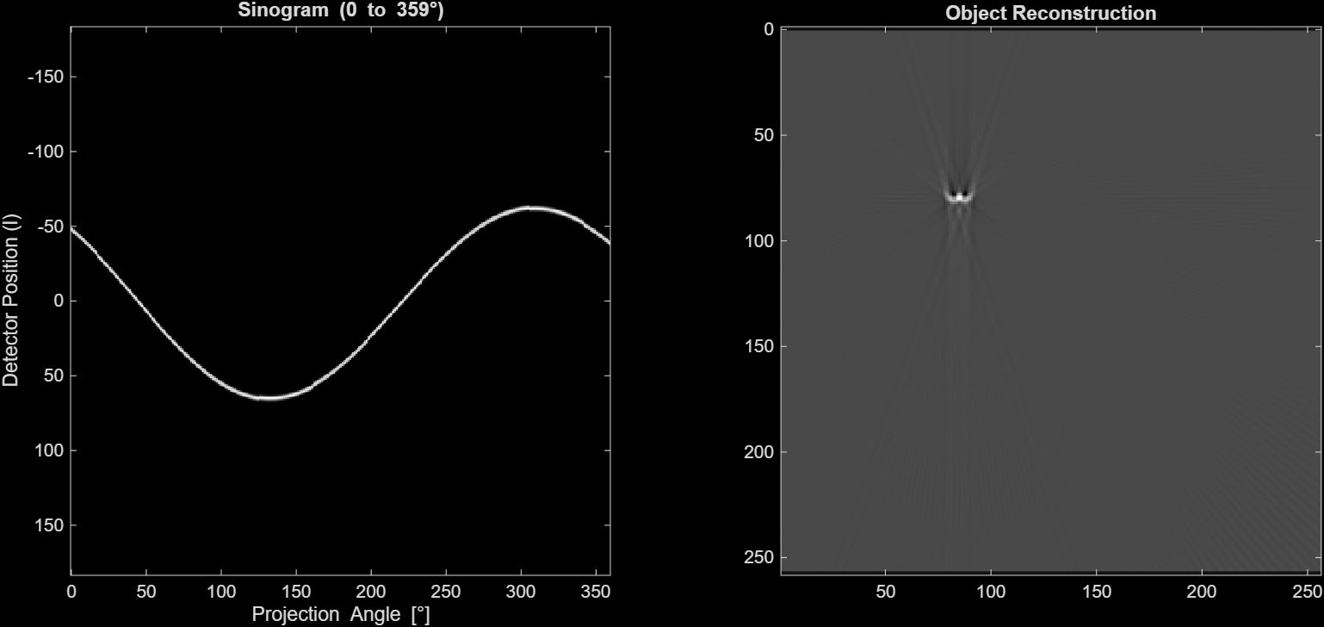
    - vx = 20 mm/s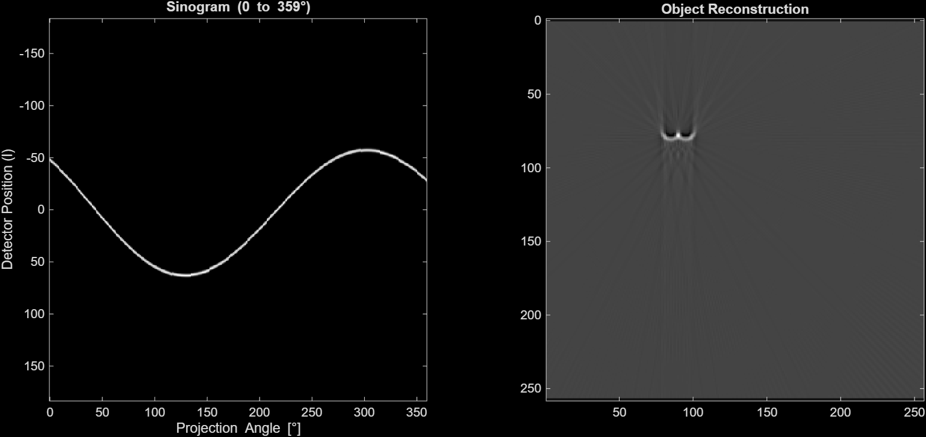

    - vx = 40mm/s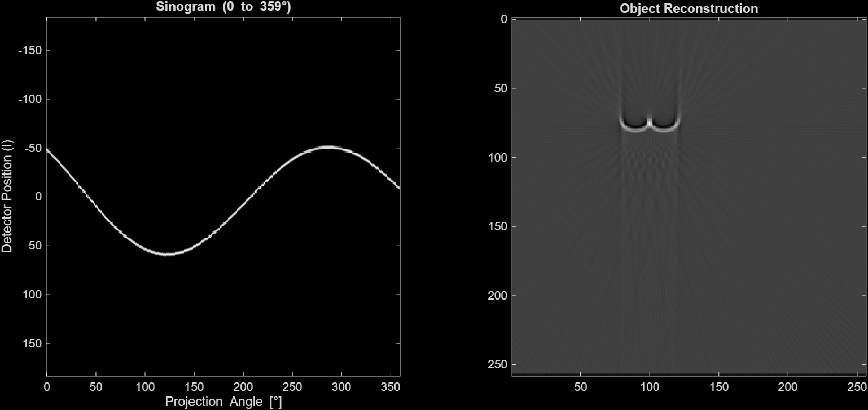

    - vx = 80 mm/s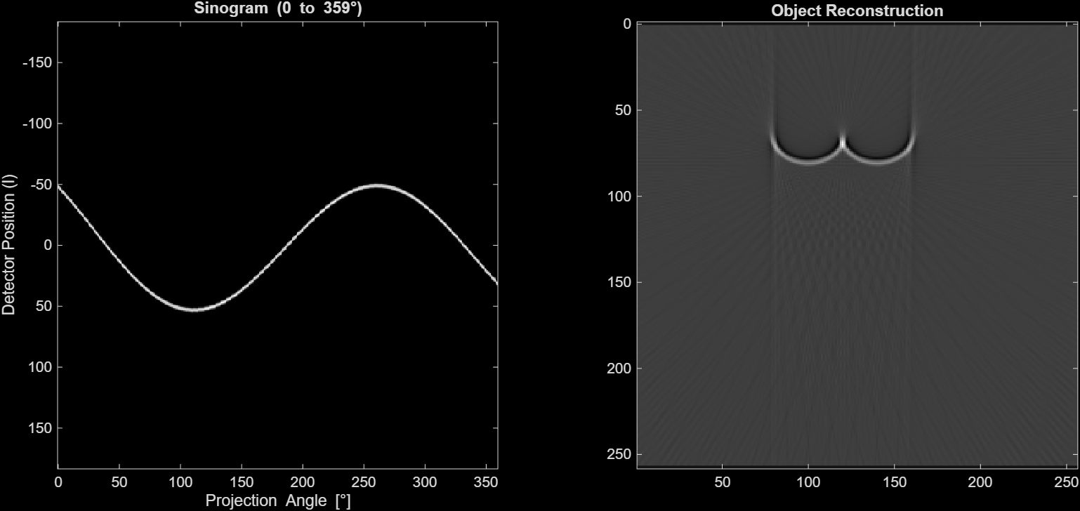

  - (4 pts) What do you observe about the reconstructed image as velocity increases? How do these artifacts compare to motion artifacts you've seen in photos taken with your cell phone?
    - As the velocity increases, the reconstructed image shows increased motion artifacts in the background where there are more linear streaks radiating from the object. The object itself is becoming a lot more blurred and it is stretching in the x direction. Originally it starts off as a white square with no motion. Then when motion starts to get introduced two lobes form on each side of the point with faint radial streaks. As more velocity is added the lobes get a broader arch and it no longer looks like a square. Overall this occurs because each projection captures the object at a different position so
    - This is very similar to a motion blur in a cell phone photo where the object appears smeared or duplicated because multiple positions are captured over time and overlap. The key difference is that CT artifacts reflect a sinusoidal geometry because of the Radon transform which is why that lonbe and radial streak pattern happens instead of a unidirectional blur.
    - As velocity increases, the reconstructed image shows progressively more severe motion artifacts. At vx = 10 mm/s, the object is nearly point-like and close to the stationary reference. By vx = 20 mm/s, it begins splitting into two distinct side-by-side lobes with faint radial streaks below. At vx = 40 mm/s the double-lobe structure widens and the streaks intensify, and by vx = 80 mm/s the lobes are widely separated into a broad arch, with the object no longer recognizable as a compact square. Overall, the object becomes increasingly blurred and stretched in the x-direction, with more linear streaks radiating outward as velocity increases. This occurs because each projection captures the object at a different position, so FBP attempts to reconcile inconsistent data — backprojecting the sinogram error across the full image — producing symmetric doubling and radial streaks rather than a simple smear.
    - This is analogous to motion blur in cell phone photos: in both cases, the object appears smeared or duplicated because multiple positions are captured over time rather than a single fixed position. The key difference is that CT artifacts reflect the sinusoidal geometry of the Radon transform, producing the characteristic lobe-and-streak pattern rather than a unidirectional blur.

    - At vx = 10 mm/s, the object is nearly point-like with mild blurring — close to the stationary reference. At vx = 20 mm/s, the object begins splitting into two distinct lobes side-by-side, with faint radial streaks appearing below. At vx = 40 mm/s, the double-lobe structure is more pronounced and wider, with stronger streak artifacts extending downward. At vx = 80 mm/s, the two lobes are spatially separated into a wide horseshoe/arch shape, and the object is no longer recognizable as a compact square.
This is directly analogous to cell phone motion blur: a stationary subject appears sharp, while a fast-moving subject smears into a streak in the direction of motion. The key difference is that in CT, because FBP backprojects each projection across the full image, the blur manifests as symmetric doubling and radial streaks rather than a simple unidirectional smear — the artifact shape reflects the sinusoidal geometry of the Radon transform rather than a single exposure direction.
    - As the velocity increases, the reconstructed image shows increasing motion artifacts. The object becomes more blurred and stretched in the direction of motion, and at higher velocities it begins to split or appear duplicated with noticeable streaking. This happens because each projection captures the object at a different position, so the reconstruction tries to combine inconsistent data.
These artifacts are similar to motion blur seen in cell phone photos when an object moves during exposure. In both cases, the object appears smeared or duplicated because multiple positions are captured over time instead of a single fixed position.

  - (5 pts) By altering one of the defined parameters in the code, can you compensate for the object motion to make the reconstructed images for 𝑣𝑥 = [20, 40, 80] 𝑚𝑚/𝑠 match the image reconstructed from 𝑣𝑥 = 10 𝑚𝑚/𝑠? Attach the sinogram and reconstructed image from your altered parameter.
    - vx = 20 mm/s; gantry_speed = 750 degrees/s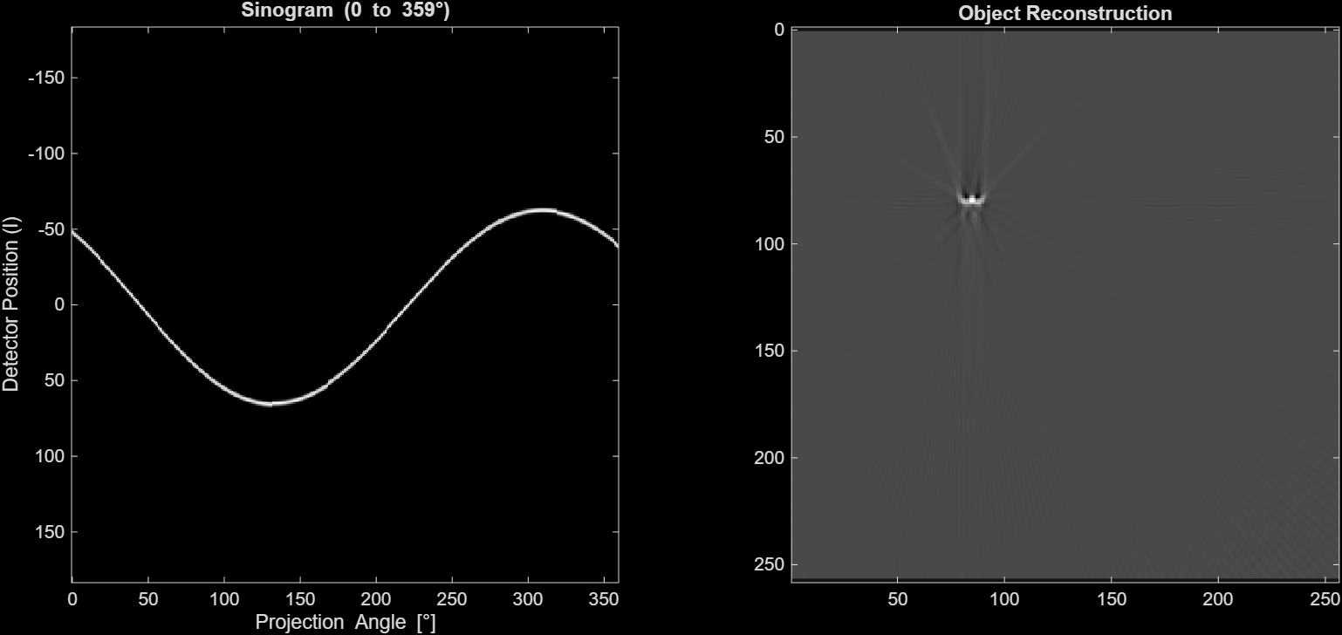

    - vx = 40 mm/s; gantry_speed = 1500 degrees/s

    - vx = 80 mm/s; gantry_speed = 3000

  - (2 pts) From the experiment above, what relationship do you infer between velocity magnitude and the parameter you altered?
    - From the compensated experiments — vx = 20 matched at 750°/s, vx = 40 at 1500°/s, vx = 80 at 3000°/s — the required gantry speed scales linearly and proportionally with velocity. Specifically, the ratio vx / gantry_speed is held constant (~0.0267 mm/s per °/s in each case). This makes physical sense: what determines artifact severity is the displacement per degree, dx/dθ = vx / gantry_speed. Keeping this ratio fixed keeps the per-projection displacement identical, reproducing the same sinogram geometry and thus the same reconstruction.
    - There is a proportional relationship between velocity magnitude and gantry speed. As the velocity increases, the gantry speed must also increase to compensate and maintain similar image quality. This is because increasing gantry speed reduces the acquisition time, which limits how far the object moves during the scan.

  - (2 pts) Is the parameter change you proposed practically feasible with current CT scanner hardware? Justify your answer.
    - No. The compensated gantry speeds required are 750, 1500, and 3000°/s. Current state-of-the-art clinical scanners top out at approximately 1500°/s (0.23 s/revolution). Reaching 3000°/s to compensate for vx = 80 mm/s would require doubling the fastest scanner available today, which is mechanically infeasible given the enormous centrifugal forces on gantry components at those rotational speeds. In clinical practice, the equivalent benefit is achieved instead through ECG gating — acquiring only during mid-diastole when coronary velocities are naturally lowest — rather than spinning the gantry faster.
    - This parameter change is not always practically feasible with current CT hardware. While modern scanners can achieve fast rotation speeds, there are mechanical and physical limits to how fast the gantry can rotate due to system stability, heat generation, and patient safety. Extremely high speeds, like those required for very high velocities in this simulation, may not be achievable in practice.

- (10 pts) This question investigates the effect of the direction of object motion on the reconstructed image. Keeping all other parameters at their default values, run the simulation for: (i) 𝑣⃗ = 40 𝑚𝑚/𝑠 in the x-direction; (ii) 𝑣⃗ = 40 𝑚𝑚/𝑠 diagonally (𝑣𝑥 =𝑣𝑦=40/√2); (iii) 𝑣⃗ = 40 𝑚𝑚/𝑠 in the y-direction.
  - (6 pts) Attach the sinogram and reconstructed image for each experiment above.
    - vx = 40 mm/s
    - vx = vy = 40/√2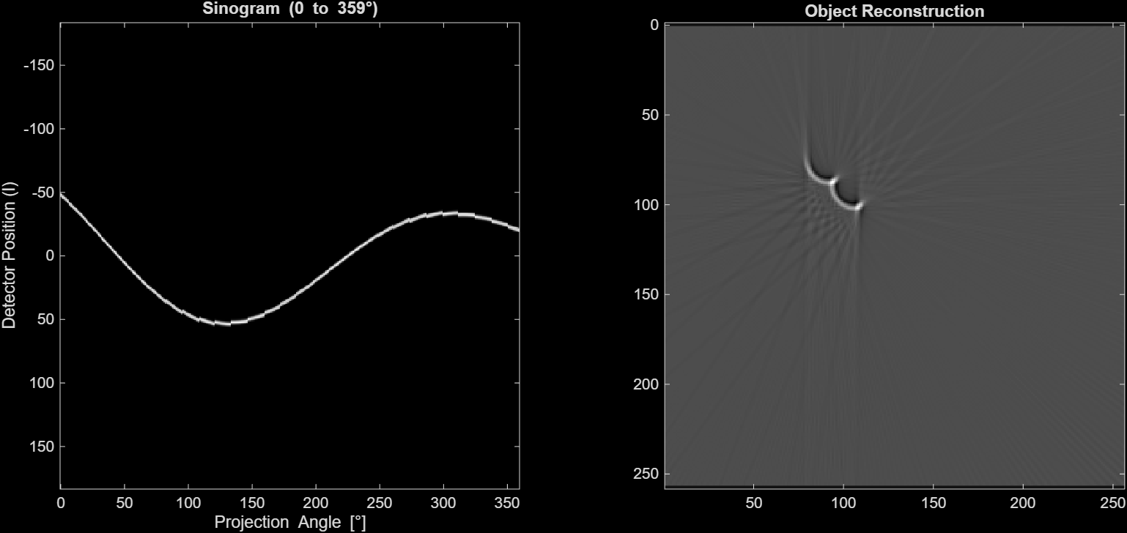

    - vy = 40 mm/s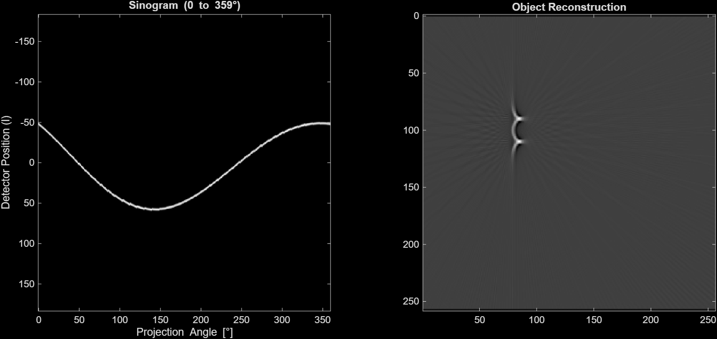

  - (4 pts) What do you observe about the differences in the reconstructed images as a function of the direction of motion?
    - Your three reconstructions show strikingly different artifact shapes despite identical speed:
      - x-direction (vx = 40): two horizontally separated lobes with downward-pointing streaks — the object is smeared laterally, reflecting displacement along the detector axis at vertical projection angles (near 0° and 180°)
      - diagonal (vx = vy = 40/√2): a single comma/hook shape with oblique streaks — the smearing is distributed across both axes, and the asymmetry reflects the fact that x and y displacements affect different projection angles differently
      - y-direction (vy = 40): a compact crescent/bracket shape with minimal lateral spread — the object is displaced along the projection ray at near-0° angles (where y-motion is invisible to the detector), so fewer projections are corrupted and the reconstruction is noticeably less distorted than the x-motion case
The key takeaway is that motion parallel to the projection ray is invisible to that projection — it produces no sinogram shift — while motion perpendicular to the ray causes maximum detector displacement. Since the gantry rotates through all angles, no direction fully escapes artifacts, but y-direction motion produces the least severe reconstruction artifact because it is "hidden" during the most heavily weighted near-0° projections.
    - The direction of motion significantly affects the appearance of motion artifacts in the reconstructed images. For motion in the x-direction, the artifacts appear as horizontal smearing and duplication of the object. For motion in the y-direction, the distortion is oriented differently and tends to produce more vertical streaking. In the diagonal case, the artifacts are asymmetric and appear more complex because the motion has components in both directions.
This happens because each projection angle interacts differently with the direction of motion, causing variations in how the object is misregistered during reconstruction.

- (12 pts) Repeat all three experiments from question B2 but now using half-scan reconstruction with 𝑎𝑛𝑔𝑢𝑙𝑎𝑟_𝑟𝑎𝑛𝑔𝑒 = 0: 179, keeping all other parameters at their default values.
  - (6 pts) Attach the sinogram and reconstructed image for each experiment.
    - vx = 40 mm/s 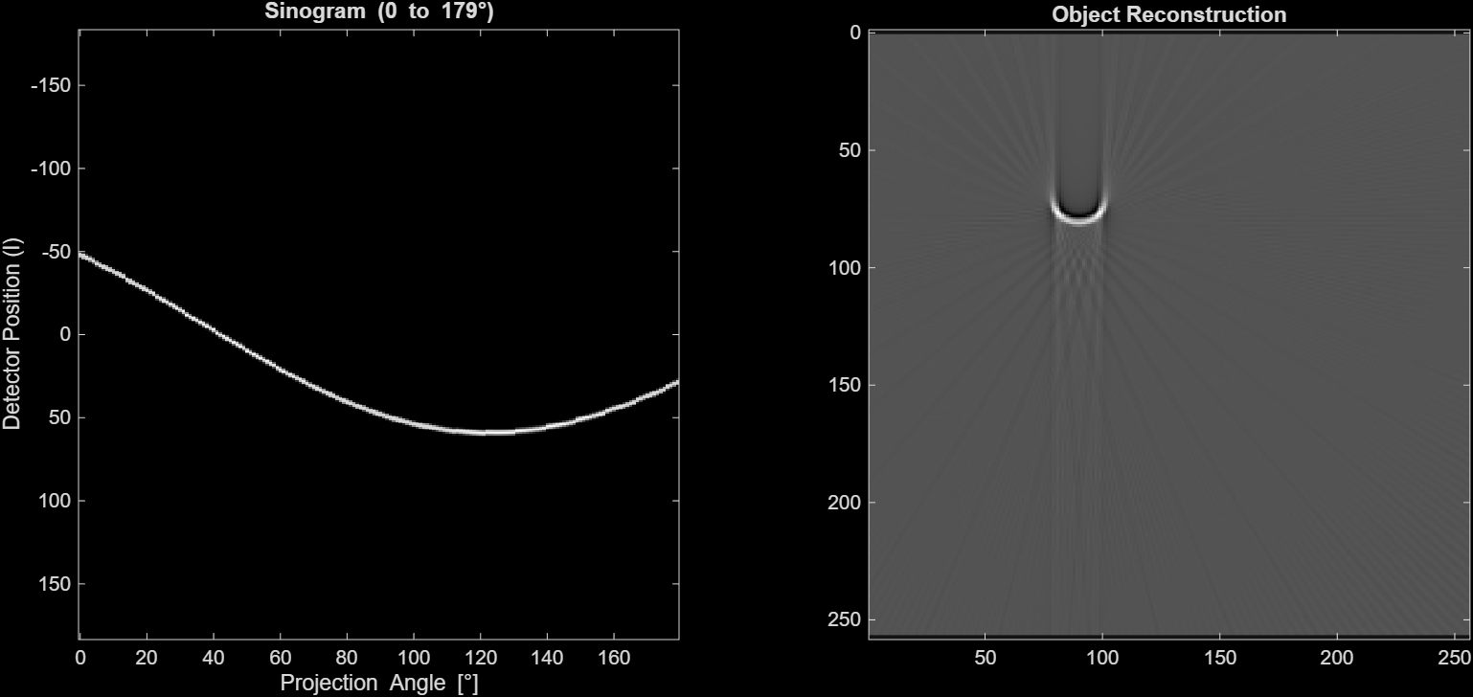

    - vx = vy = 40/√2 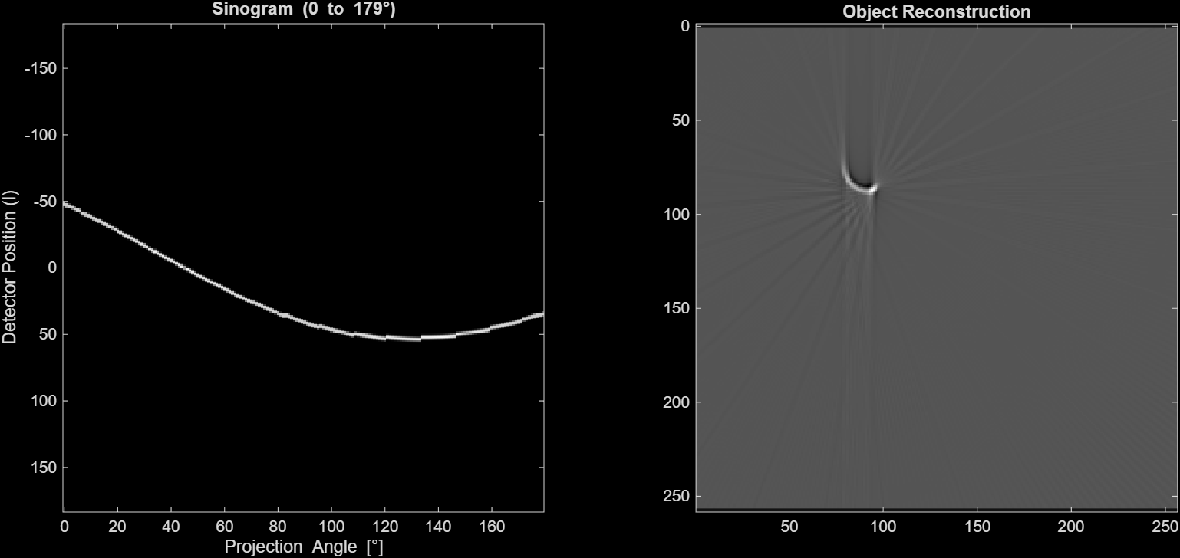
    - vy = 40 mm/s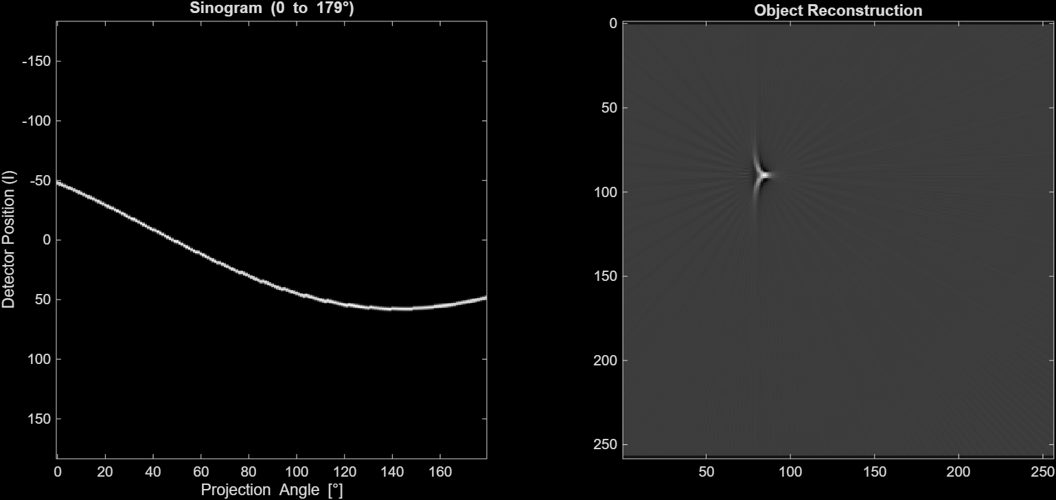

  - (2 pts) What is your main takeaway from comparing half-scan vs full-scan reconstruction?
    - The half-scan (0°–179°) reduces total acquisition time by half, which directly reduces the total displacement of the object during the scan. Comparing your B3 reconstructions to B2: the artifacts are less severe across all three motion directions — the lobes are closer together, streaks are shorter, and the object is more compact. However, the half-scan also samples fewer angles, so the reconstructions show slight asymmetry and mild directional bias not present in the full-scan. The trade-off favors the half-scan in cardiac imaging: the benefit of freezing motion by shortening acquisition time outweighs the modest loss in angular completeness.
    - The main takeaway is that half-scan reconstruction generally produces fewer motion artifacts compared to full-scan reconstruction because it uses a shorter acquisition time. Since the object moves less during the shorter scan window, there is less inconsistency between projections, leading to improved image quality.
  - (4 pts) If you had control over the object's velocity direction and magnitude, which set of motion parameters from the three experiments performed would you choose to maximize the fidelity of the information contained in the image? Justify your answer.
    - From your half-scan results, vy = 40 mm/s (pure y-direction) produces by far the most faithful reconstruction — your image shows a nearly point-like object with only a tiny residual artifact, whereas x-direction and diagonal motion still produce visible lobes and streaks. This is the best choice because during a 0°–179° half-scan, the projection rays at early angles (near 0°) are oriented vertically, meaning y-direction displacement runs parallel to those rays and is largely undetected. The combination of shortened acquisition time (half-scan) and motion oriented along the dominant ray direction minimizes the number of projections that register a positional shift, maximizing reconstruction fidelity.
    - To maximize image fidelity, I would choose motion primarily in the y-direction with the smallest possible velocity. In the experiments, the y-direction motion produced fewer visible distortions compared to x-direction or diagonal motion, likely because it interacts differently with the projection geometry. Additionally, minimizing the velocity reduces the amount of displacement during the scan, which reduces motion artifacts.

- (10 pts) You now get your hands on a scanner with a much faster gantry, having 𝑔𝑎𝑛𝑡𝑟𝑦_𝑠𝑝𝑒𝑒𝑑 = 1000°/𝑠. Run the simulation using half-scan reconstruction (𝑎𝑛𝑔𝑢𝑙𝑎𝑟_𝑟𝑎𝑛𝑔𝑒 = 0: 179) for (i) 𝑣⃗ = 40 𝑚𝑚/𝑠 in the x-direction and (ii) 𝑣⃗ = 40 𝑚𝑚/𝑠 in the y-direction, keeping all other parameters at their default values.
  - (4 pts) Attach the sinogram and reconstructed image for each experiment.
    - vx = 40 mm/s 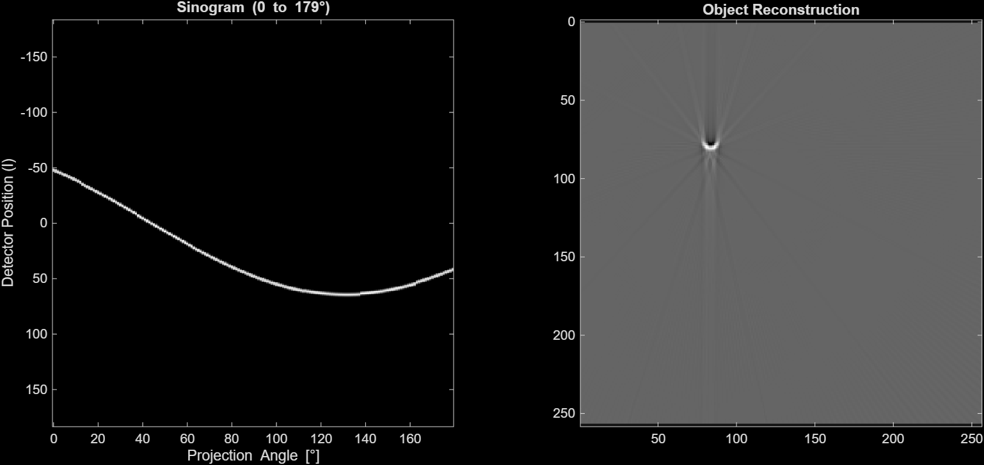
    - vx = vy = 40/√2 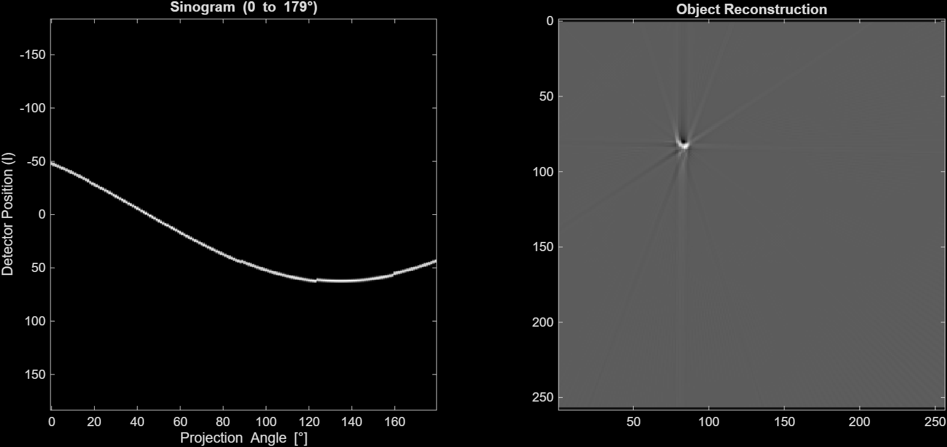
    - vy = 40 mm/s 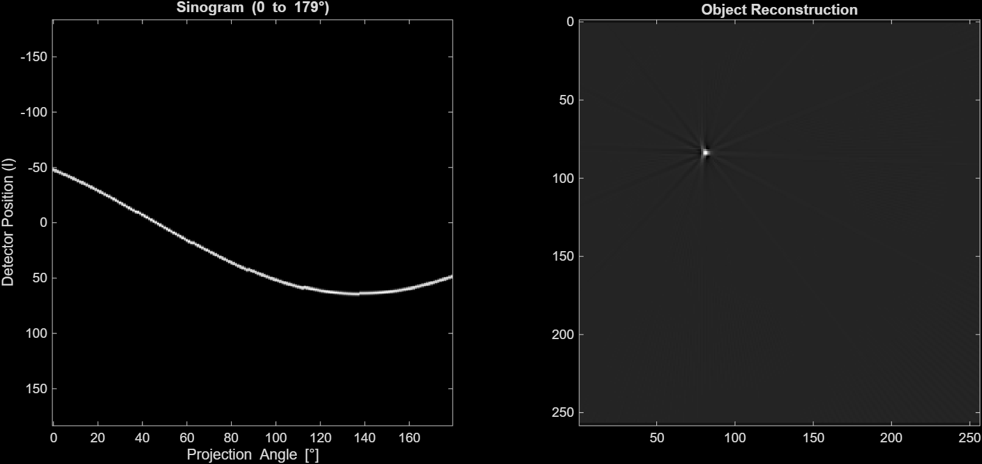

  - (2 pts) Describe key differences between the x-motion and y-motion reconstructed images.
    - With the fast gantry (1000°/s, half-scan), both reconstructions improve dramatically over the 360°/s case, but important differences remain. The x-motion reconstruction shows a small but distinct downward-pointing streak below the object — the object is slightly elongated vertically with a tail artifact. The y-motion reconstruction is nearly indistinguishable from the no-motion reference, with only the faintest positional asymmetry. The x-motion artifact persists because horizontal displacement still shifts the detector position significantly during near-vertical projections (0° and 180°), even over the shortened acquisition. Y-motion, as before, runs parallel to these same rays and is nearly invisible to them, so the fast gantry's reduced acquisition time is sufficient to make residual y-displacement negligible.
    - The x-direction motion shows more noticeable smearing and duplication of the object, while the y-direction motion produces less severe distortion and appears more localized. The difference is due to how the motion aligns with the projection angles, causing different levels of inconsistency in the measured projections.

  - (4 pts) Using simple sketches (hand-drawn or computer generated), can you provide a clear explanation of the origin of these differences?
    - The diagram above illustrates the core principle. At θ = 0° (vertical rays), x-motion shifts the object perpendicular to the ray — the detector records it at a different position, corrupting that sinogram column. Y-motion shifts the object parallel to the ray — the detector still intercepts it at the same position, so no shift is recorded. At θ = 90° the situation reverses. Since the half-scan covers only 0°–179°, near-vertical angles (θ ≈ 0° and near 180°) are heavily represented. X-motion corrupts these critical early and late columns, and FBP backprojects the error vertically — producing the downward streak. Y-motion is invisible to most of these columns, so far fewer projections are corrupted and the reconstruction stays clean.
    - The difference originates from how the object moves relative to the projection rays. In x-direction motion, the object shifts along the detector direction, causing large changes in projection position between angles. In y-direction motion, the displacement is less aligned with the detector direction, so the projections remain more consistent. This results in less severe artifacts for y-motion.

- (16 pts) In this question, we will examine the effect of object acceleration on motion artifacts. Keeping all parameters at their default values, produce a total displacement 𝑆 = 80 𝑚𝑚 purely in the x-direction using two different motion profiles: (i) constant velocity (𝑎⃗ = 0) and (ii) pure acceleration (𝑣⃗ = 0). You will need to use the kinematic equation to find the corresponding 𝑣𝑥 and 𝑎𝑥 values – use the 𝑔𝑎𝑛𝑡ry_𝑠𝑝𝑒𝑒𝑑 and 𝑎𝑛𝑔𝑢𝑙𝑎𝑟_𝑟𝑎𝑛𝑔𝑒 to determine the total acquisition time 𝑡, then use 𝑡 in the kinematic equation.
  - (4 pts) Report your calculated values for 𝑣𝑥, 𝑎𝑥, and 𝑡. Show your working.
%% Part B
% B5-----------------------------------------------------------------------
% Default Paramaters
% Equation: S = v*t + (1/2) * a * t^2;
angular_range = 0:359;
gantry_speed = 360;

% Total Displacement
S = 80; % mm

% Total acquisition time
dt = 1/gantry_speed;
num_projections = length(angular_range);
t = num_projections * dt;
disp(t)

% Profile (i) constant velocity (a = 0)
a = 0;
v = (S - (1/2)*a*t^2)/t;
disp(v)

% Profile (ii) constant accelaration (v = 0)
v = 0;
a = (S - v*t) * 2 / t^2;
disp(a)
    - vx = 80 mm/s
    - ax = 160 mm/s^2
    - t = 1s
  - (4 pts) Attach the sinogram and reconstructed image for each experiment. 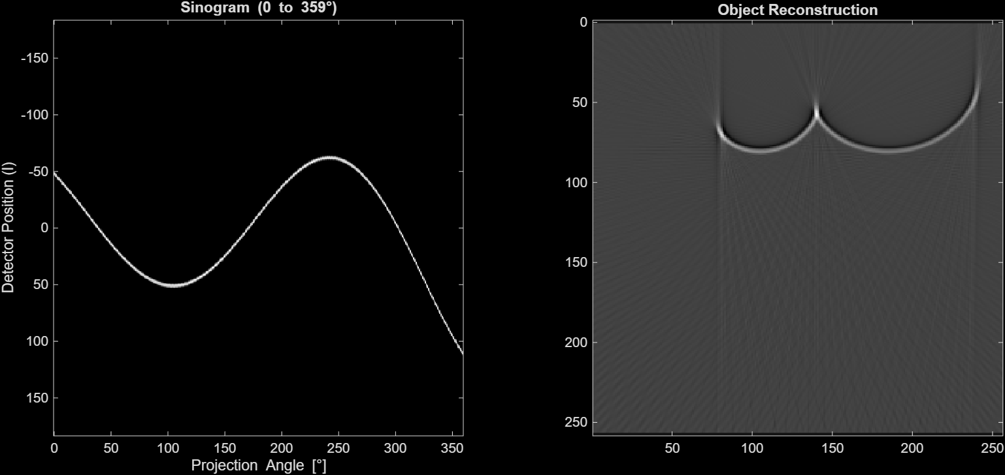

  - (4 pts) Describe key differences in the reconstructed images between the constant velocity and pure acceleration experiments. Briefly explain the origin of these differences, despite the total displacement being the same in both cases.
    - Despite identical total displacement, the two reconstructions look strikingly different. In the constant velocity case, the object moves at a uniform rate — each projection captures the same incremental shift — so the sinogram bright line is smoothly and uniformly curved, and FBP produces a symmetric smear spread evenly across the object's path. In the pure acceleration case, the object barely moves at the start of the scan and moves very rapidly toward the end. Early projections are nearly stationary, while late projections contain large positional errors. This produces a curved (parabolic) sinogram and an asymmetric reconstruction: one edge of the artifact is relatively sharp (corresponding to early, near-stationary projections) while the other is heavily smeared (corresponding to late, fast-moving ones). The origin of the difference is purely temporal: the distribution of motion over time determines which projection angles are most corrupted, and FBP has no way to distinguish these cases without explicit motion information.
    - The constant velocity case shows more uniform blurring and smoother distortion, while the pure acceleration case shows more severe and asymmetric streaking artifacts. Even though the total displacement is the same in both cases, the acceleration case causes the object to move slowly at first and then much faster toward the end of the scan.
This creates greater inconsistency between projections, since later projections capture the object at significantly different positions. Because CT reconstruction assumes a stationary object, these inconsistencies lead to stronger artifacts in the acceleration case.

  - (4 pts) Considering all of the above experiments, at what phase of the cardiac cycle would you recommend acquiring the cardiac CT image, and why?
    - Mid-diastole — the rest phase between heartbeats (~70–80% of the R-R interval). During systole, coronary velocities reach 60–100 mm/s with significant acceleration as the heart transitions between phases; your B1 and B5 experiments both demonstrate that both high velocity and non-zero acceleration dramatically worsen artifacts. Mid-diastole minimizes both simultaneously: coronary velocities drop below ~20 mm/s and acceleration is near zero, placing the motion regime in the same range as your low-artifact vx = 10 mm/s reference case. ECG gating exploits this natural rest window to acquire projections only when cardiac motion is slowest, directly applying the principle demonstrated across all your experiments.
    - The best time to acquire a cardiac CT image is during mid-diastole, when both velocity and acceleration of the heart are lowest. From the experiments, we see that lower motion and especially lower acceleration lead to fewer artifacts. Since the heart experiences minimal motion during this phase, it produces the most consistent projections and therefore the highest image quality.

- Provide a brief paragraph summarizing your understanding of motion artifacts in CT, discussing the interplay between motion magnitude and direction, gantry speed and position, and half-scan vs full-scan reconstruction.
  - Motion artifacts in CT arise because filtered backprojection assumes a stationary object throughout the acquisition, but each projection captures the object at a slightly different spatial position when motion is present. The severity of artifacts scales directly with velocity magnitude — as demonstrated in B1, higher velocities produce wider smearing and more pronounced doubling as the per-projection displacement increases. The direction of motion critically determines artifact morphology: motion perpendicular to a projection ray maximally shifts the detector signal, while motion parallel to the ray goes entirely undetected by that projection. Since the gantry sweeps all angles, no direction fully escapes artifacts in a full scan, but y-direction motion during a half-scan (B3) showed the least distortion because it aligns with the dominant near-vertical ray directions. Gantry speed and scan duration are intimately coupled to artifact severity — faster rotation shortens acquisition time and reduces total displacement, as confirmed in B4, though hardware limits make this insufficient alone for high-velocity motion. Half-scan reconstruction (B3, B4) further reduces the temporal acquisition window and consistently improves image quality at the cost of only modest angular incompleteness. Finally, B5 revealed that the temporal distribution of motion matters independently of total displacement: pure acceleration produces asymmetric, parabolic sinogram distortion and non-uniform reconstruction artifacts distinct from those of constant-velocity motion. Together, these findings explain why cardiac CT combines fast gantry rotation with ECG-gated acquisition during mid-diastole — the phase where coronary velocity and acceleration are both minimized — to achieve the highest fidelity reconstructions of small coronary structures.
  - Motion artifacts in CT arise when the object moves during data acquisition, causing inconsistencies between projections that violate the assumption of a stationary object. As motion magnitude increases, artifacts such as blurring, streaking, and duplication become more severe. The direction of motion also plays a role, since it affects how the object interacts with projection angles and detector alignment. Faster gantry speeds reduce acquisition time, which helps minimize motion effects. Additionally, half-scan reconstruction improves image quality compared to full-scan by shortening the time window over which motion occurs. Overall, minimizing both velocity and acceleration is critical for reducing motion artifacts and achieving high-quality CT images.

Appendix A: Reference Images
Part B: Experiments (80 points)
- Display the reconstructed image of the 3 x 3 square object using the default parameters (no motion).
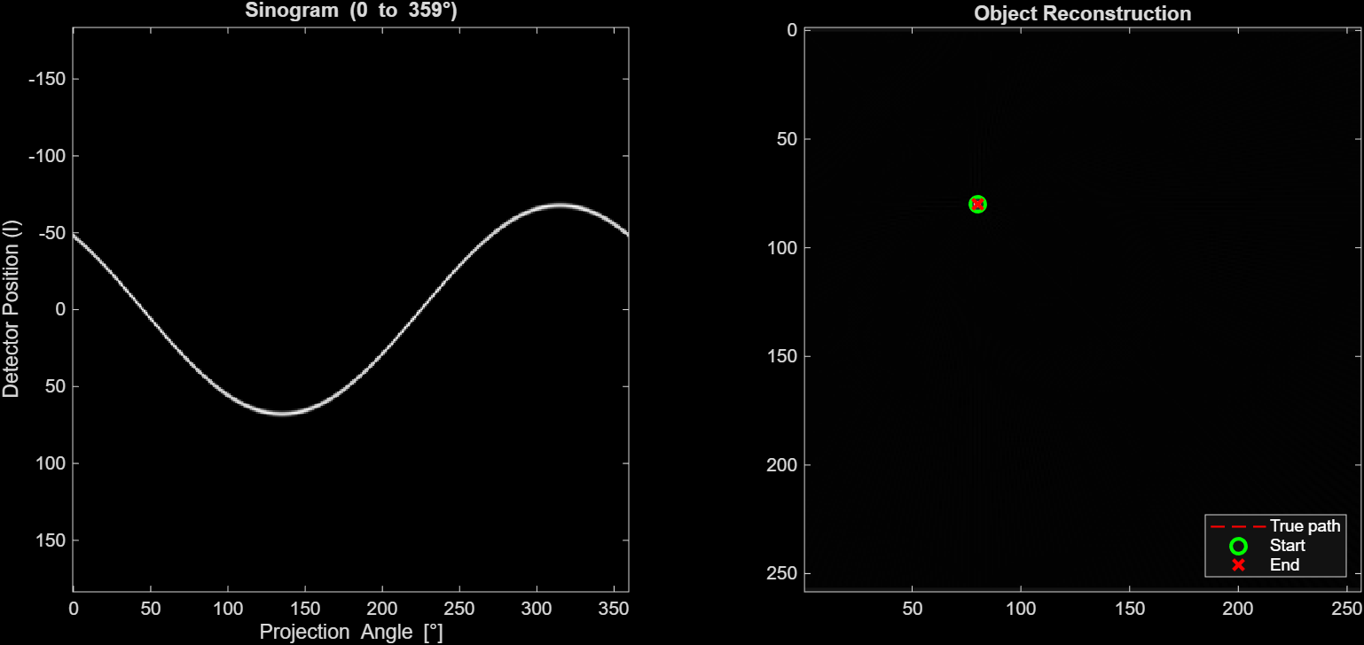

- Keeping all other parameters at their default values, run the simulation for 𝑣⃗ = [10, 20, 40, 80] 𝑚𝑚/𝑠 in the x-direction, i.e., 𝑣𝑦 = 0.
  - (8 pts) Attach the sinogram and reconstructed image for each velocity.
    - vx = 10mm/s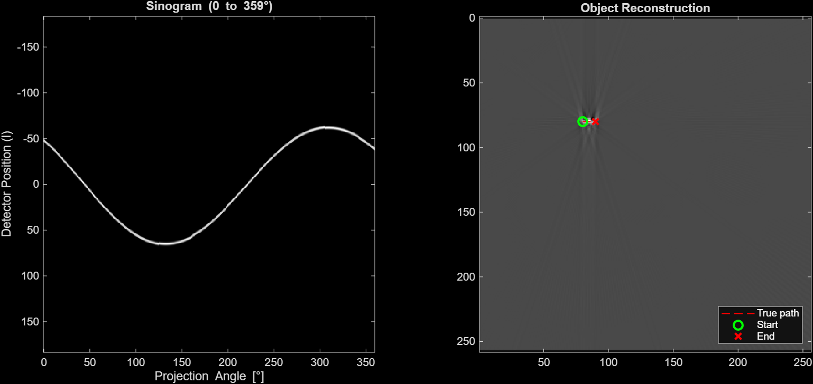
    - vx = 20 mm/s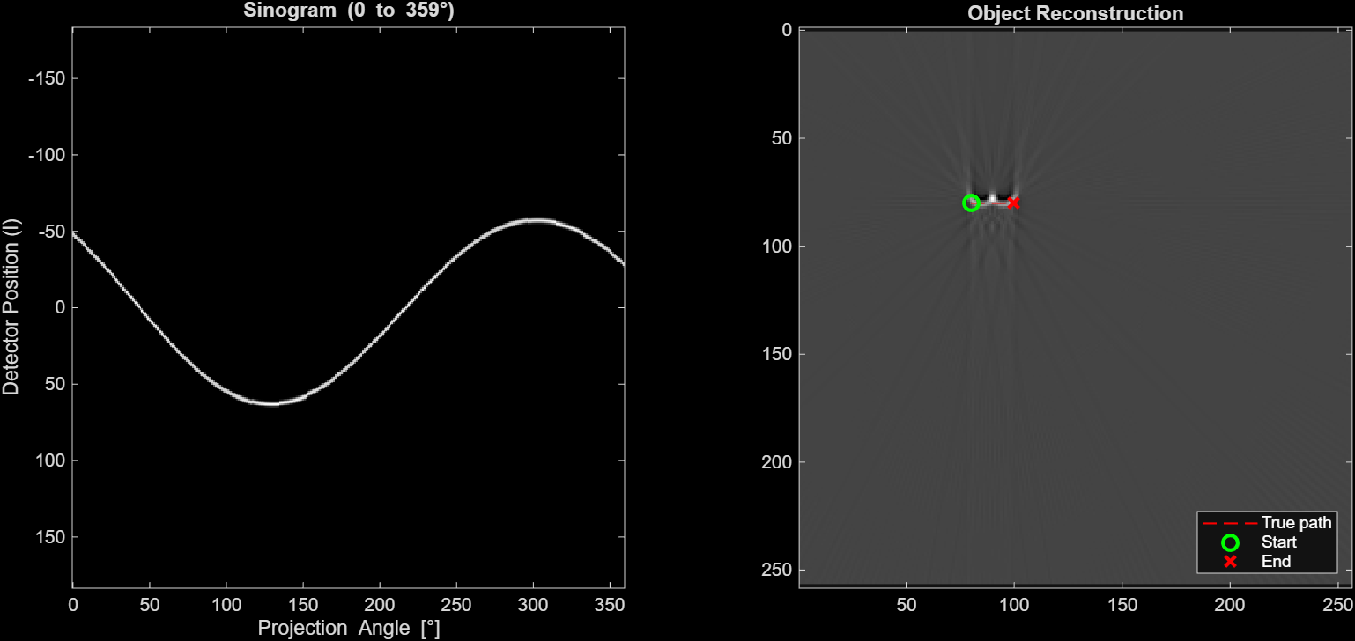
    - vx = 40mm/s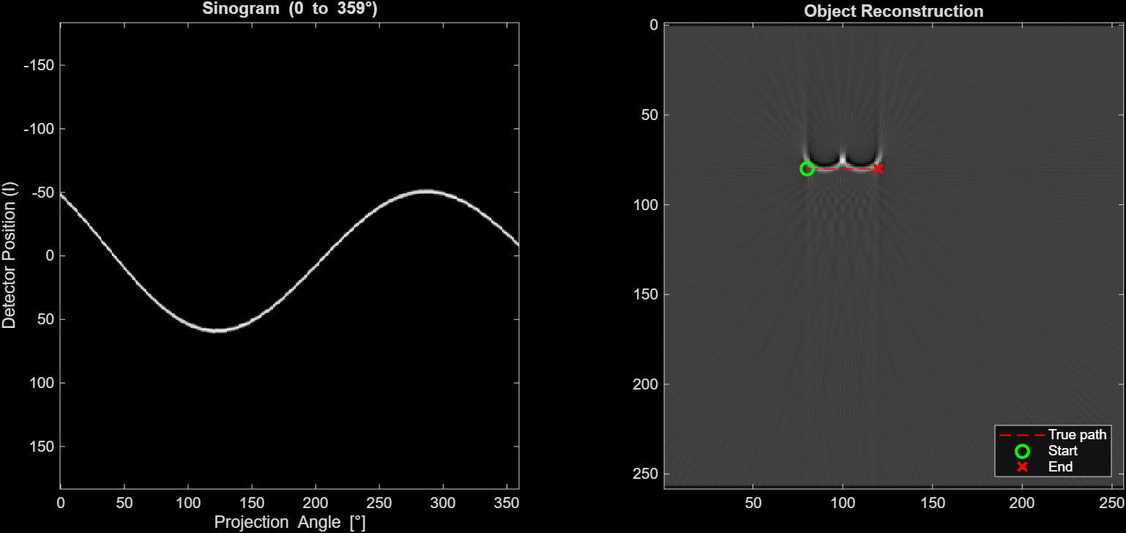
    - vx = 80 mm/s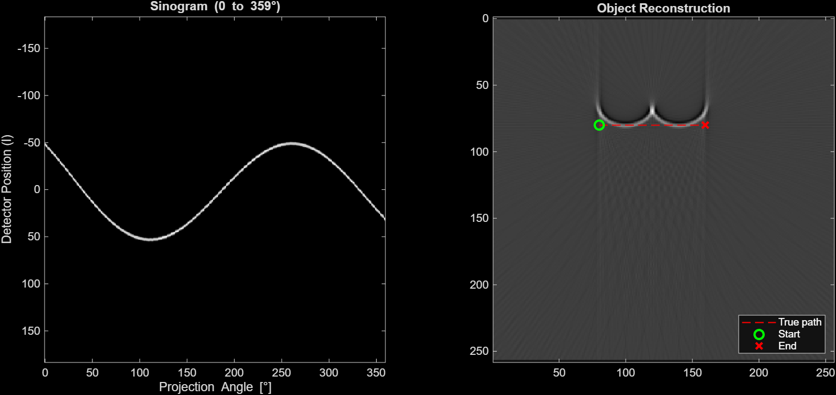

  - ------------------------------------------------------------------------------------------------
  - (5 pts) By altering one of the defined parameters in the code, can you compensate for the object motion to make the reconstructed images for 𝑣𝑥 = [20, 40, 80] 𝑚𝑚/𝑠 match the image reconstructed from 𝑣𝑥 = 10 𝑚𝑚/𝑠? Attach the sinogram and reconstructed image from your altered parameter.
    - vx = 20 mm/s; gantry_speed = 750 degrees/s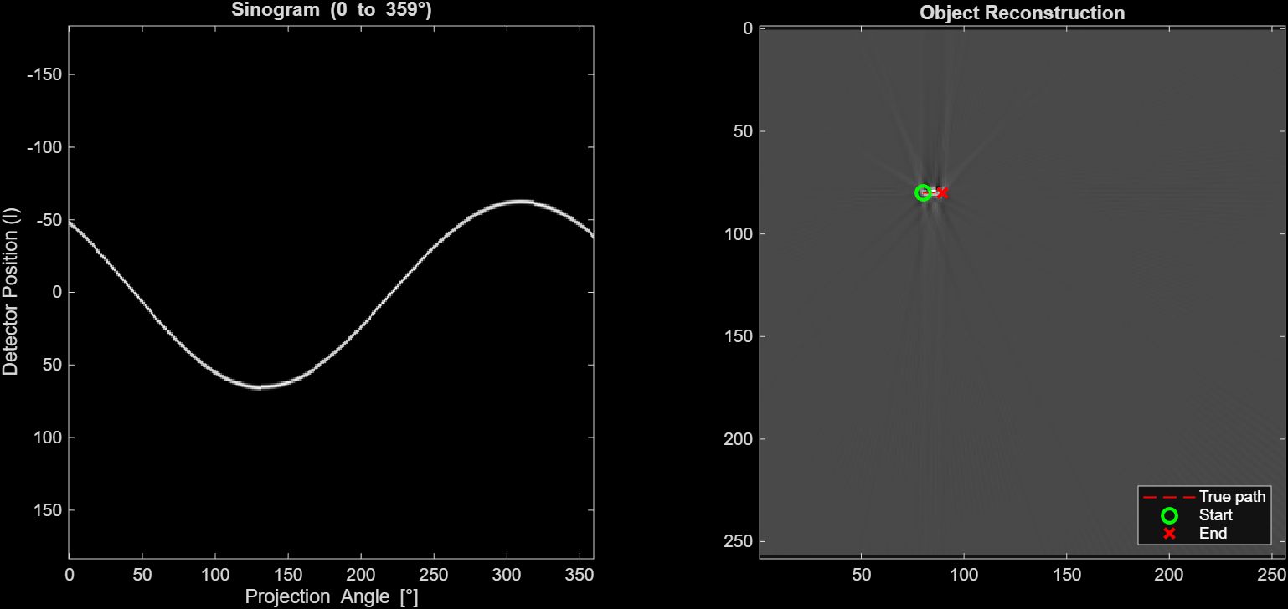
    - vx = 40 mm/s; gantry_speed = 1500 degrees/s

    - vx = 80 mm/s; gantry_speed = 3000
  - ------------------------------------------------------------------------------------------------
  - ------------------------------------------------------------------------------------------------

- (10 pts) This question investigates the effect of the direction of object motion on the reconstructed image. Keeping all other parameters at their default values, run the simulation for: (i) 𝑣⃗ = 40 𝑚𝑚/𝑠 in the x-direction; (ii) 𝑣⃗ = 40 𝑚𝑚/𝑠 diagonally (𝑣𝑥 =𝑣𝑦=40/√2); (iii) 𝑣⃗ = 40 𝑚𝑚/𝑠 in the y-direction.
  - (6 pts) Attach the sinogram and reconstructed image for each experiment above.
    - vx = 40 mm/s
    - vx = vy = 40/√2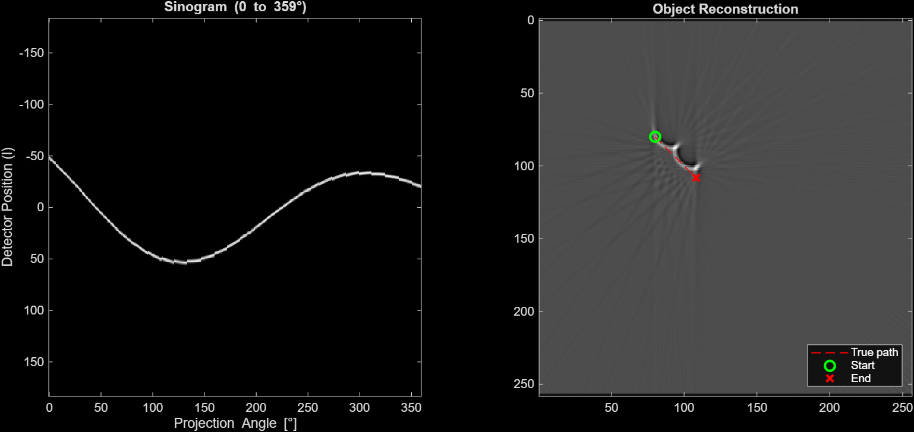
    - vy = 40 mm/s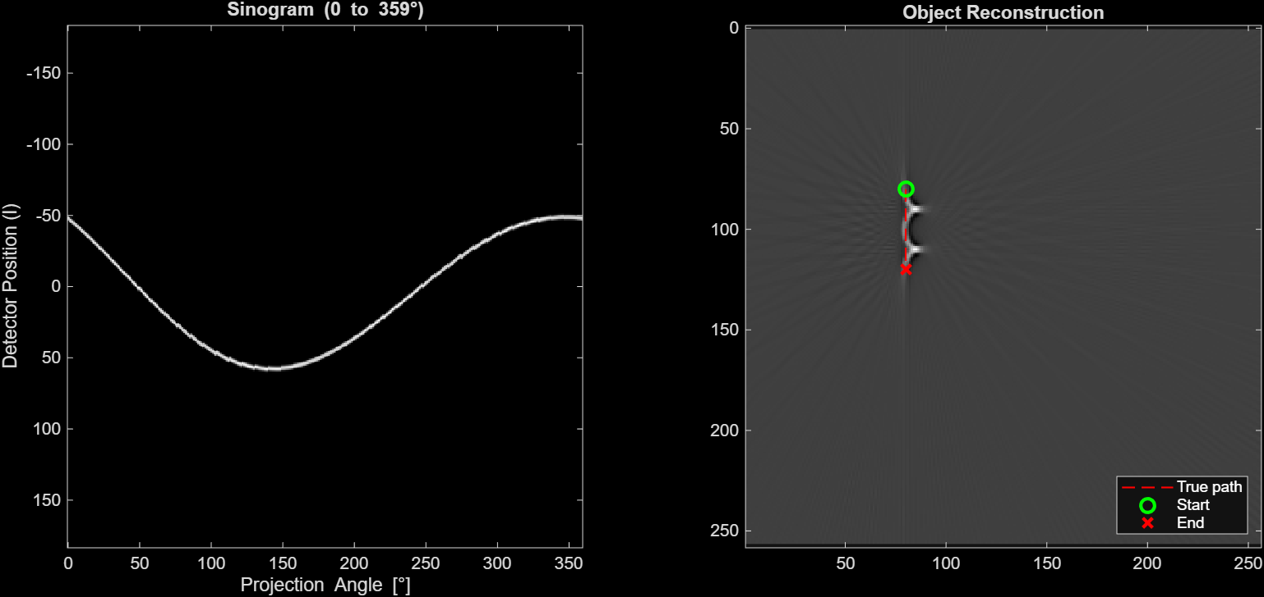
  - ------------------------------------------------------------------------------------------------

- (12 pts) Repeat all three experiments from question B2 but now using half-scan reconstruction with 𝑎𝑛𝑔𝑢𝑙𝑎𝑟_𝑟𝑎𝑛𝑔𝑒 = 0: 179, keeping all other parameters at their default values.
  - (6 pts) Attach the sinogram and reconstructed image for each experiment.
    - vx = 40 mm/s 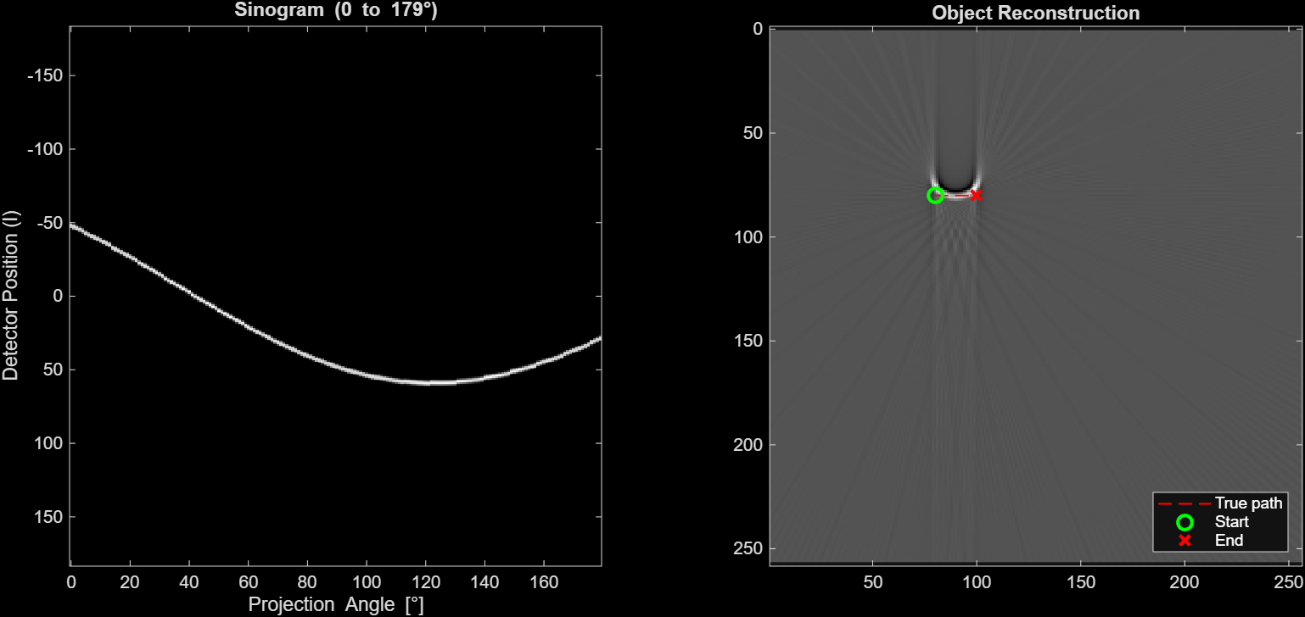
    - vx = vy = 40/√2 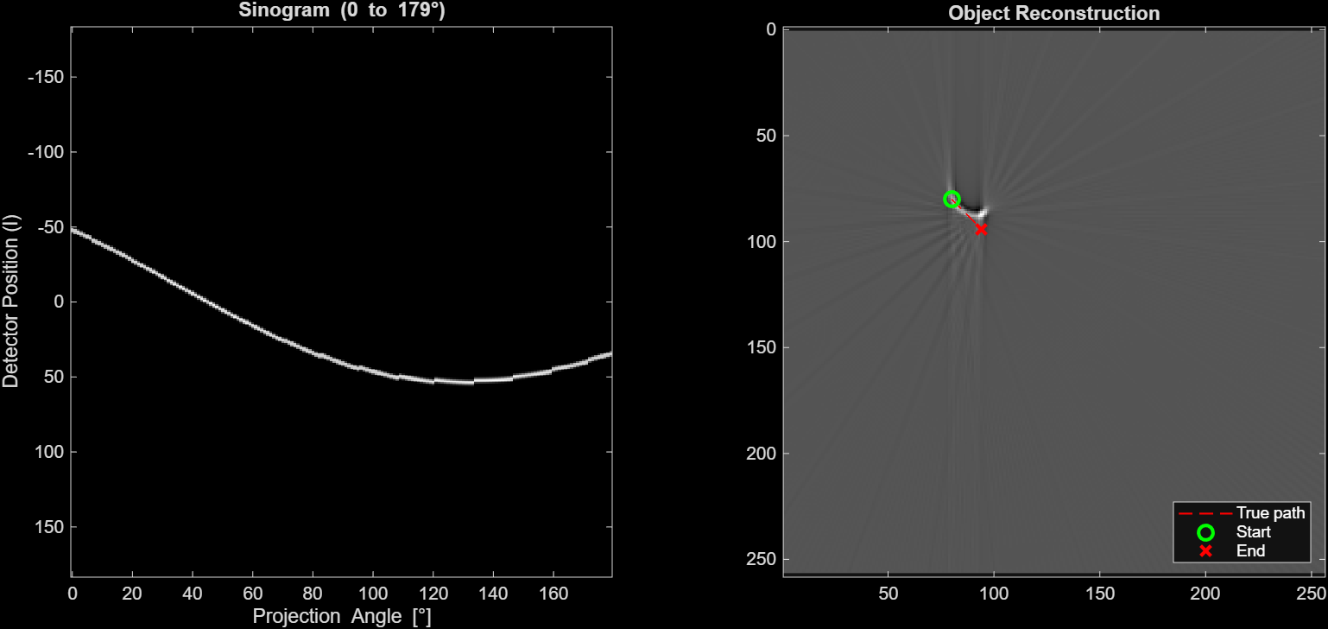
    - vy = 40 mm/s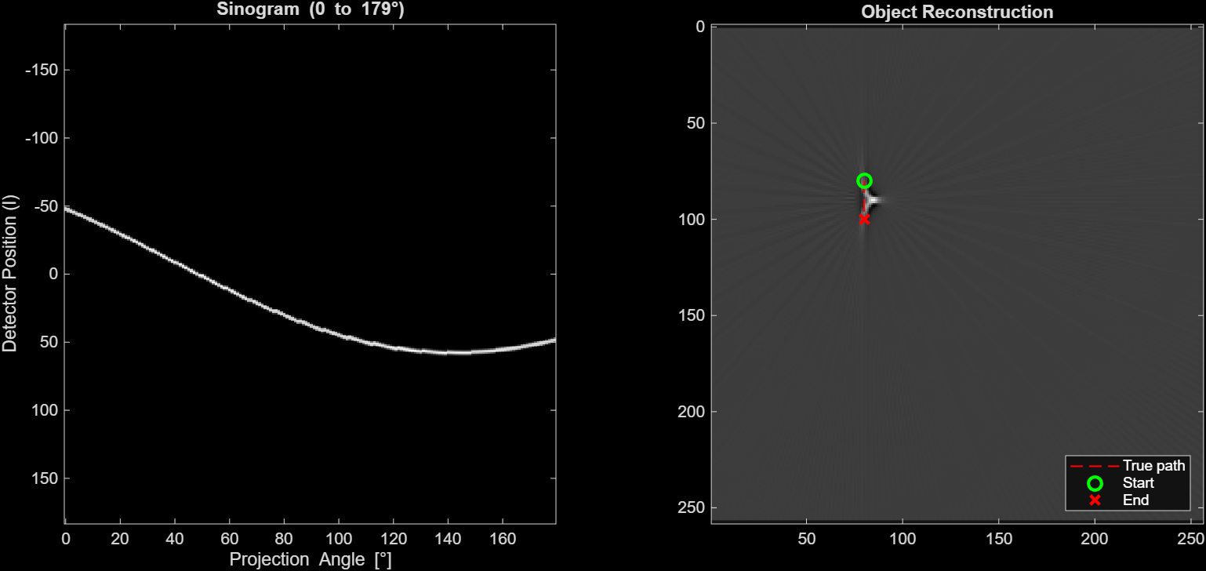

  - ------------------------------------------------------------------------------------------------
  - ------------------------------------------------------------------------------------------------

- (10 pts) You now get your hands on a scanner with a much faster gantry, having 𝑔𝑎𝑛𝑡𝑟𝑦_𝑠𝑝𝑒𝑒𝑑 = 1000°/𝑠. Run the simulation using half-scan reconstruction (𝑎𝑛𝑔𝑢𝑙𝑎𝑟_𝑟𝑎𝑛𝑔𝑒 = 0: 179) for (i) 𝑣⃗ = 40 𝑚𝑚/𝑠 in the x-direction and (ii) 𝑣⃗ = 40 𝑚𝑚/𝑠 in the y-direction, keeping all other parameters at their default values.
  - (4 pts) Attach the sinogram and reconstructed image for each experiment.
    - vx = 40 mm/s 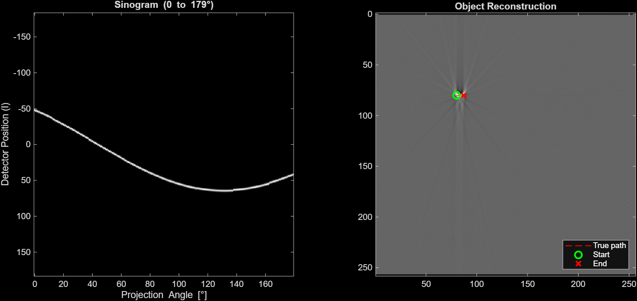
    - vx = vy = 40/√2 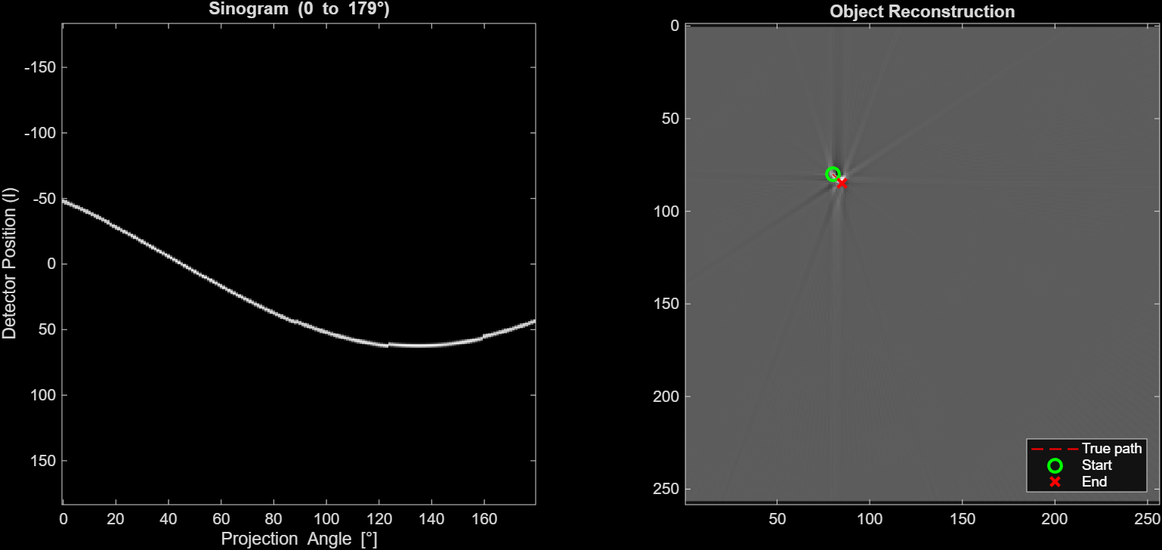
    - vy = 40 mm/s 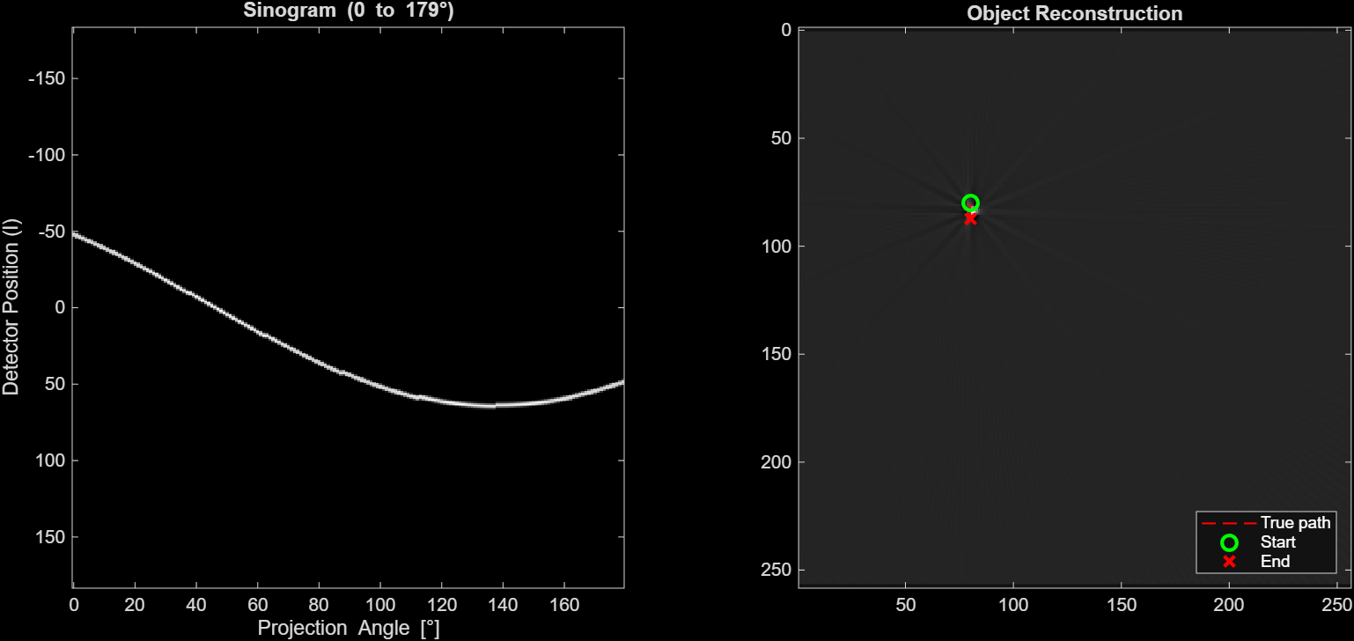
  - ------------------------------------------------------------------------------------------------
  - ------------------------------------------------------------------------------------------------

- (16 pts) In this question, we will examine the effect of object acceleration on motion artifacts. Keeping all parameters at their default values, produce a total displacement 𝑆 = 80 𝑚𝑚 purely in the x-direction using two different motion profiles: (i) constant velocity (𝑎⃗ = 0) and (ii) pure acceleration (𝑣⃗ = 0). You will need to use the kinematic equation to find the corresponding 𝑣𝑥 and 𝑎𝑥 values – use the 𝑔𝑎𝑛𝑡ry_𝑠𝑝𝑒𝑒𝑑 and 𝑎𝑛𝑔𝑢𝑙𝑎𝑟_𝑟𝑎𝑛𝑔𝑒 to determine the total acquisition time 𝑡, then use 𝑡 in the kinematic equation.
  - ------------------------------------------------------------------------------------------------
  - (4 pts) Attach the sinogram and reconstructed image for each experiment.
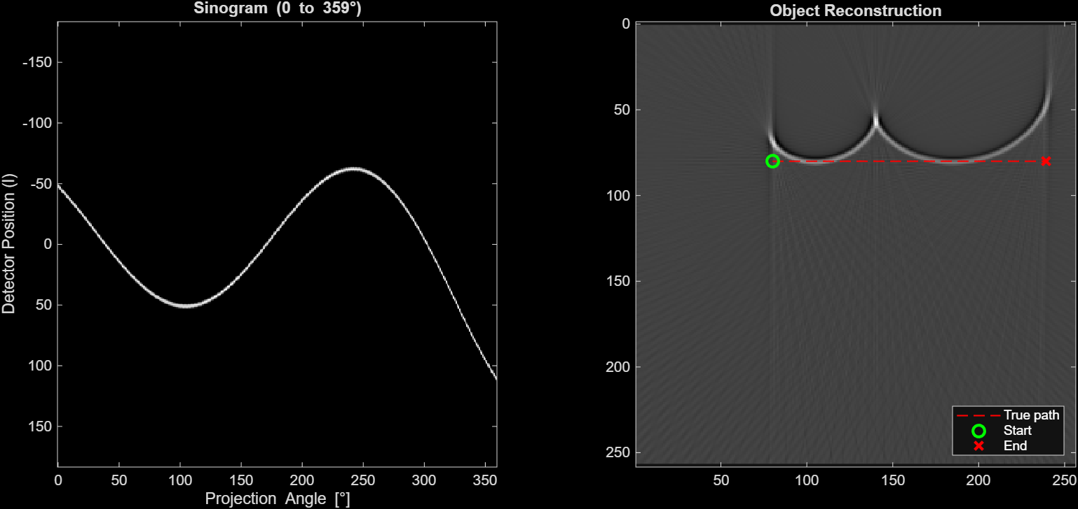
  - ------------------------------------------------------------------------------------------------

  - ------------------------------------------------------------------------------------------------
Appendix B: MATLAB Code
%% Part A
% A1-----------------------------------------------------------------------
% Caclulate total acquisition time
gantry_speed = 540; % degrees/s
dt = 1/gantry_speed;
angular_range = 0:179; % 180 projections
num_projections = length(angular_range);
total_acquisition_time = num_projections * dt;
disp(total_acquisition_time)

% A2-----------------------------------------------------------------------
% Calculate the total displacement of the object in mm and in pixels
vx = 40; % mm/s
vy = 40; % mm/s
ax = 40; % mm/s
ay = 40; % mm/s^2
t = total_acquisition_time;
Sx = vx*t + (1/2) * ax * t^2;
Sy = vy*t + (1/2) * ay * t^2;
% Magnitude (not really needed since Sx=Sy)
S = sqrt(Sx^2 + Sy^2);
disp(S)

% Convert to pixels
pixel_spacing = 0.5; % mm
S_pixels = S/pixel_spacing;
disp(S_pixels)

%% Part B
% B5-----------------------------------------------------------------------
% Calculate vx, ax, and t
% Default Paramaters
% Equation: S = v*t + (1/2) * a * t^2;
angular_range = 0:359; % Change this for full (359)/half-scan(179)
gantry_speed = 360; % degrees per secon; deffault = 360

% Total Displacement
S = 80; % mm

% Total acquisition time
dt = 1/gantry_speed;
num_projections = length(angular_range);
t = num_projections * dt;
disp(t)

% Profile (i) constant velocity (a = 0)
a = 0;
v = (S - (1/2)*a*t^2)/t;
disp(v)

% Profile (ii) constant accelaration (v = 0)
v = 0;
a = (S - v*t) * 2 / t^2;
disp(a)

%% CT Simulation of Coronary Artery Motion
clear; clc; close all;

% Image and object parameters
N = 256; % Image size (pixels)
pixel_size = 1; % mm per pixel
obj_size = 3; % in pixels
% -------------------------------------------------------------------------
% Only required to change vx, vy, ax, ay, angular_range, and gantry_speed
% Velocity parameters
vx = 80; % x-velocity mm/s (positive = rightward)
vy = 0; % y-velocity mm/s (positive = downward in image)

% Acceleration (mm/s^2) - set to 0 for constant velocity
ax = 160; % x-acceleration
ay = 0; % y-acceleration

% A4-----------------------------------------------------------------------
% Acquisition parameters
angular_range = 0:359; % Change this for full (359)/half-scan(179)
gantry_speed = 360; % degrees per secon; deffault = 360
% -------------------------------------------------------------------------

% Starting position (pixels)
start_col = 80; % starting column (x)
start_row = 80; % starting row (y)

% Calculating object position at each projection
dt = 1/gantry_speed; % time per degree (seconds)
times = (0:length(angular_range)-1).*dt;

% Kinematics: S = v*t + 0.5*a*t^2
dx = (vx.*times + (0.5*ax)*times.^2)./pixel_size; % displacement in pixels
dy = (vy.*times + (0.5*ay)*times.^2)./pixel_size;

% Updated object positions during motion
col_positions = start_col + dx;
row_positions = start_row + dy;

% Generate sinogram
% Determine detector size from a test projection
test_img = zeros(N);
test_img(round(start_row),round(start_col)) = 1;
[~,l] = radon(test_img,0);
n_detector = length(l);

% Initializing sinogram
sinogram = zeros(n_detector,length(angular_range));
half_obj = floor(obj_size/2);

% A3 ----------------------------------------------------------------------
% Looping over each projection angle
for j = 1:length(angular_range)
img = zeros(N);
col_pos = round(col_positions(j));
row_pos = round(row_positions(j));

% Check object is fully inside image - shouldn't go out of bounds
if col_pos > half_obj && col_pos <= N-half_obj && ...
row_pos > half_obj && row_pos <= N-half_obj
img(row_pos-half_obj:row_pos+half_obj, ...
col_pos-half_obj:col_pos+half_obj) = 1;
end

% Stacking each projection in the sinogram
sinogram(:,j) = radon(img,angular_range(j));
end

% Reconstructuction
recon = iradon(sinogram,angular_range,'Ram-Lak',N);

% Displaying results
figure('pos',[10 10 1200 500]);

subplot(1,2,1);
imagesc(angular_range,l,sinogram);
xlabel('Projection Angle [\circ]');
ylabel('Detector Position (l)');
title(sprintf('Sinogram (%d to %d\\circ)',angular_range(1), ...
angular_range(end)));
colormap gray;
axis tight;

subplot(1,2,2);
imagesc(recon);
axis equal;
title('Object Reconstruction');
colormap gray;

% FOR YOUR REFERENCE ONLY: overlaying true trajectory on reconstruction
% DO NOT INCLUDE THIS IN YOUR SUBMISSION
hold on;
plot(col_positions,row_positions,'r--','LineWidth',1);
plot(start_col, start_row,'go','MarkerSize',8,'LineWidth',2);
plot(col_positions(end),row_positions(end),'rx','MarkerSize',8,'LineWidth',2);
legend('True path','Start','End','Location','southeast','TextColor','w');
hold off;

